Session-1

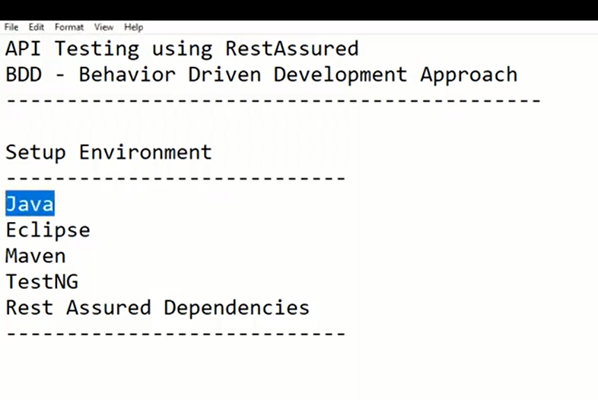

Create New Maven Project through Eclipse

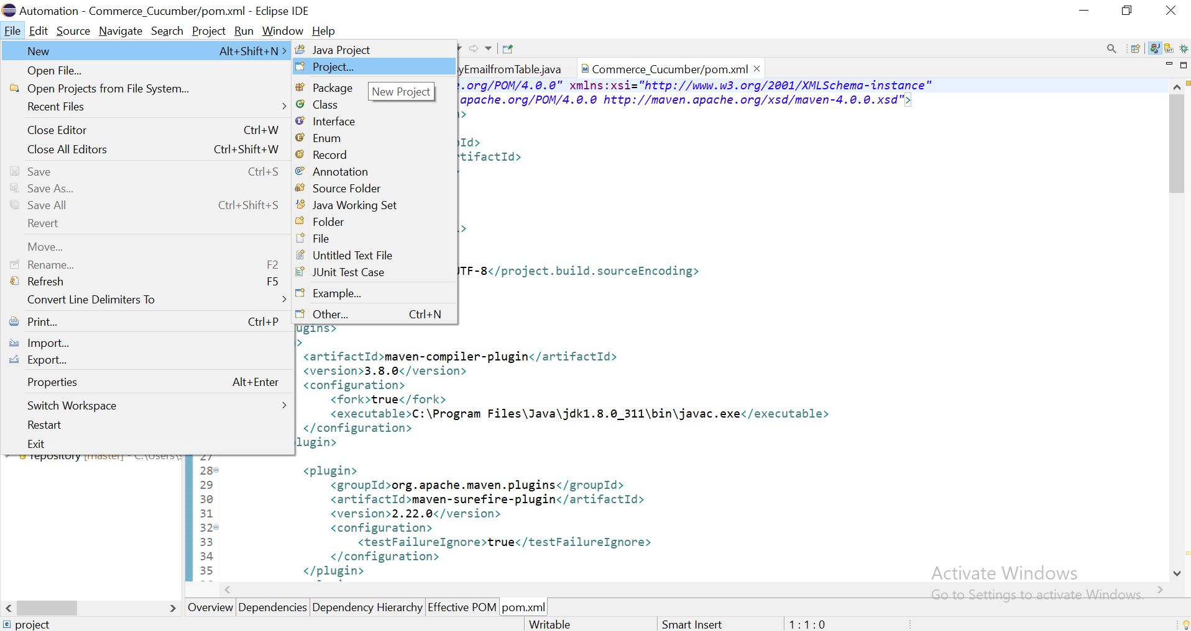

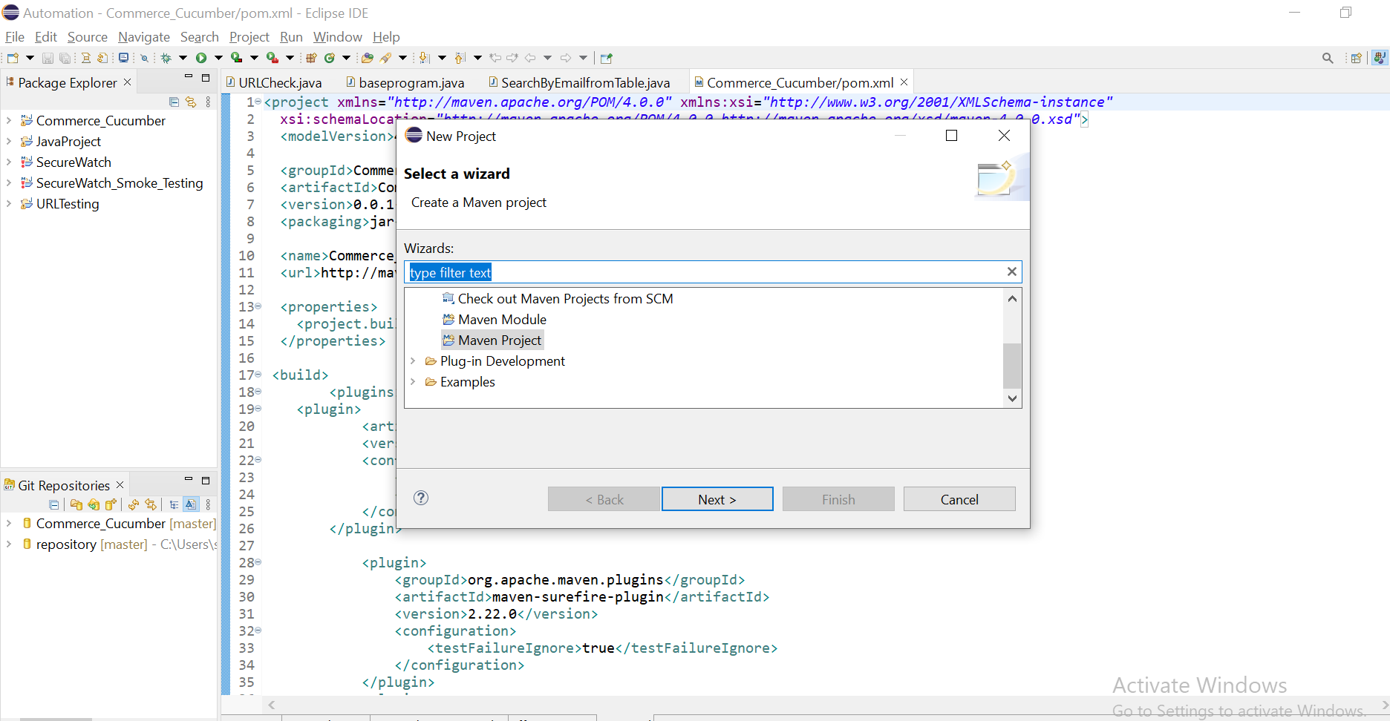

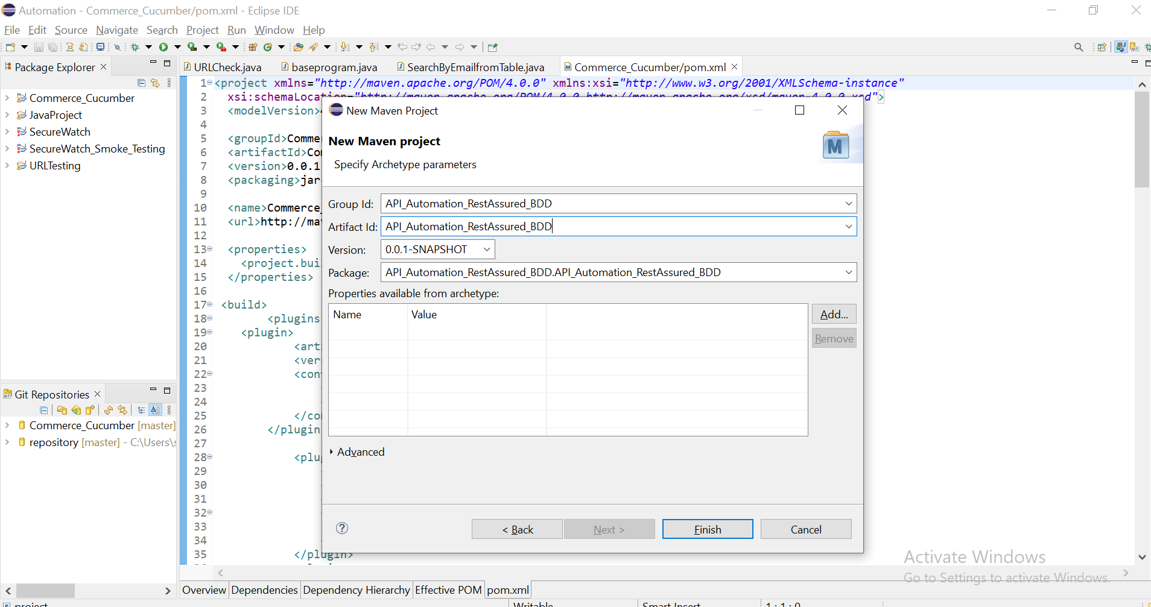

Project Created.

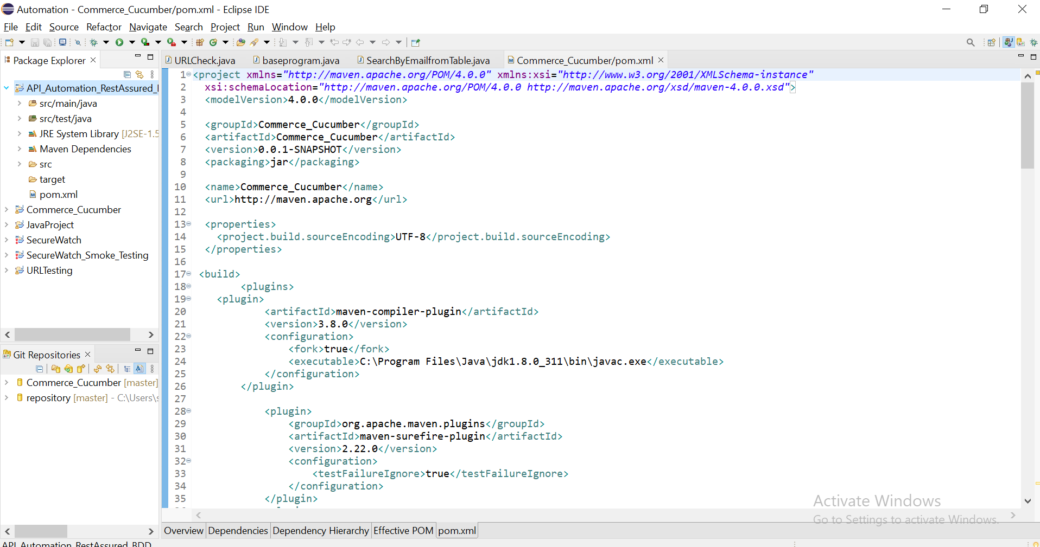

Add Rest Assured Dependencies in POM.XML file

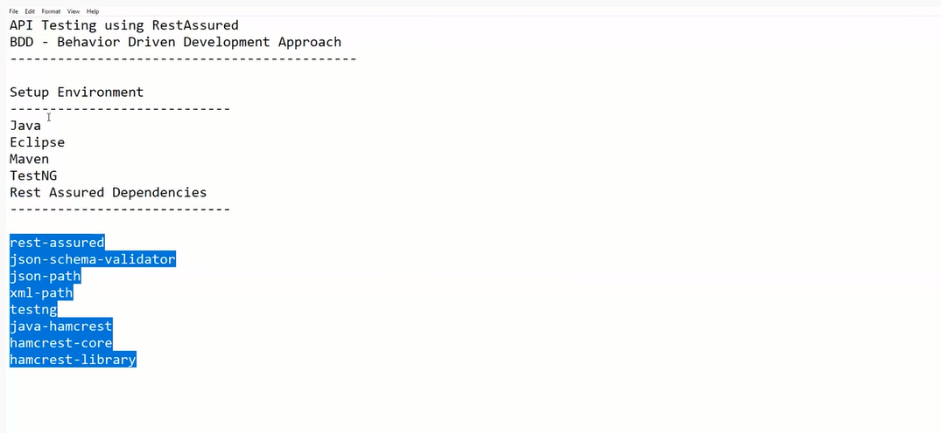

After adding all dependencies, click on save button

……….

<project xmlns=*"http://maven.apache.org/POM/4.0.0"* xmlns:xsi=*"http://www.w3.org/2001/XMLSchema-instance"*

xsi:schemaLocation=*"http://maven.apache.org/POM/4.0.0 http://maven.apache.org/xsd/maven-4.0.0.xsd"*>

<modelVersion>4.0.0</modelVersion>

<groupId>API_Automation_RestAssured_BDD</groupId>

<artifactId>API_Automation_RestAssured_BDD</artifactId>

<version>0.0.1-SNAPSHOT</version>

<packaging>jar</packaging>

<name>API_Automation_RestAssured_BDD</name>

<url>http://maven.apache.org</url>

<properties>

<project.build.sourceEncoding>UTF-8</project.build.sourceEncoding>

</properties>

<dependencies>

<!-- https://mvnrepository.com/artifact/io.rest-assured/rest-assured -->

<dependency>

<groupId>io.rest-assured</groupId>

<artifactId>rest-assured</artifactId>

<version>5.0.1</version>

<scope>test</scope>

</dependency>

<!-- https://mvnrepository.com/artifact/io.rest-assured/json-schema-validator -->

<dependency>

<groupId>io.rest-assured</groupId>

<artifactId>json-schema-validator</artifactId>

<version>5.0.1</version>

</dependency>

<!-- https://mvnrepository.com/artifact/io.rest-assured/json-path -->

<dependency>

<groupId>io.rest-assured</groupId>

<artifactId>json-path</artifactId>

<version>5.0.1</version>

</dependency>

<!-- https://mvnrepository.com/artifact/io.rest-assured/xml-path -->

<dependency>

<groupId>io.rest-assured</groupId>

<artifactId>xml-path</artifactId>

<version>5.0.1</version>

</dependency>

<!-- https://mvnrepository.com/artifact/org.testng/testng -->

<dependency>

<groupId>org.testng</groupId>

<artifactId>testng</artifactId>

<version>7.5</version>

<scope>test</scope>

</dependency>

<!-- https://mvnrepository.com/artifact/org.hamcrest/java-hamcrest -->

<dependency>

<groupId>org.hamcrest</groupId>

<artifactId>java-hamcrest</artifactId>

<version>2.0.0.0</version>

<scope>test</scope>

</dependency>

<!-- https://mvnrepository.com/artifact/org.hamcrest/hamcrest-core -->

<dependency>

<groupId>org.hamcrest</groupId>

<artifactId>hamcrest-core</artifactId>

<version>2.2</version>

<scope>test</scope>

</dependency>

<!-- https://mvnrepository.com/artifact/org.hamcrest/hamcrest-library -->

<dependency>

<groupId>org.hamcrest</groupId>

<artifactId>hamcrest-library</artifactId>

<version>2.2</version>

<scope>test</scope>

</dependency>

</dependencies>

</project>

………………….

Then Right click on project and select maven--> Update project

It will download all required jar files related to dependencies.

Then Create New Package under src/test/java

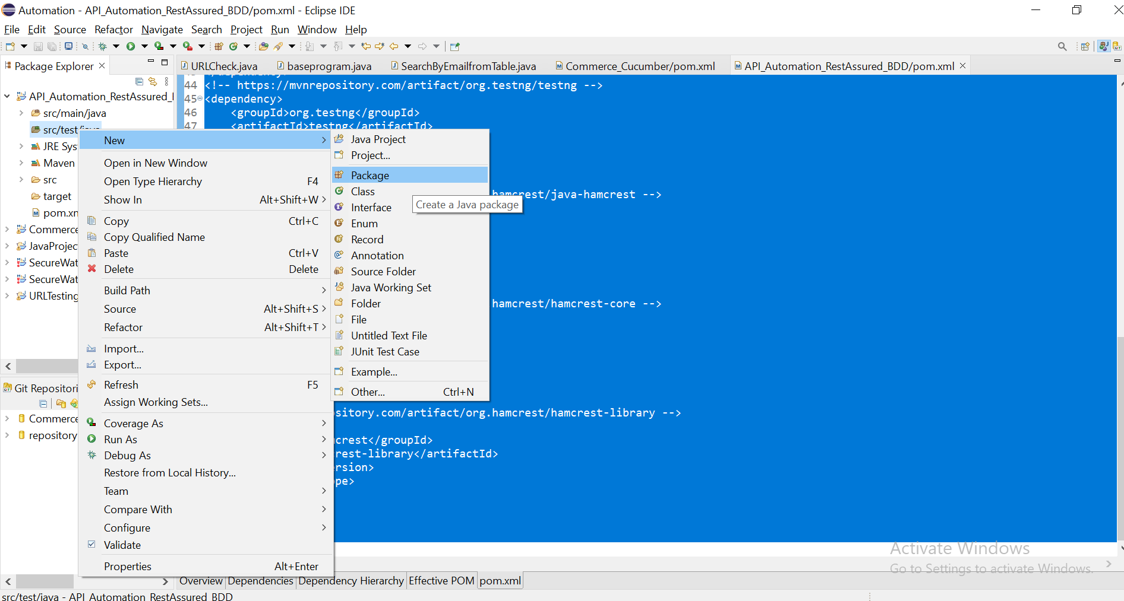

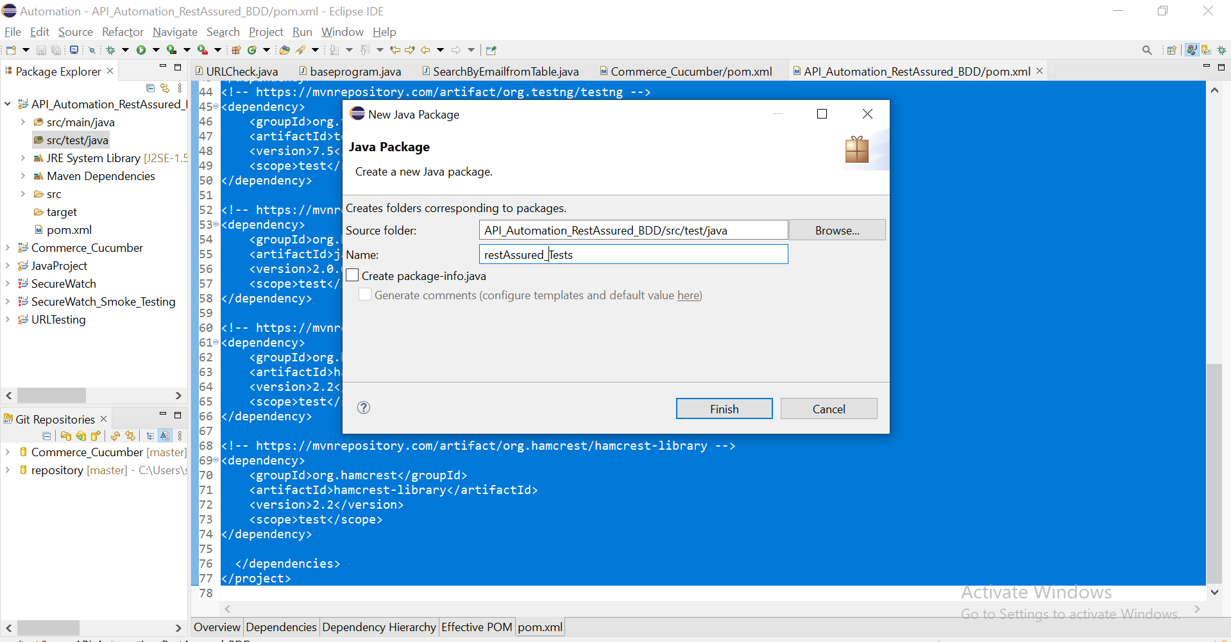

Click on finish button

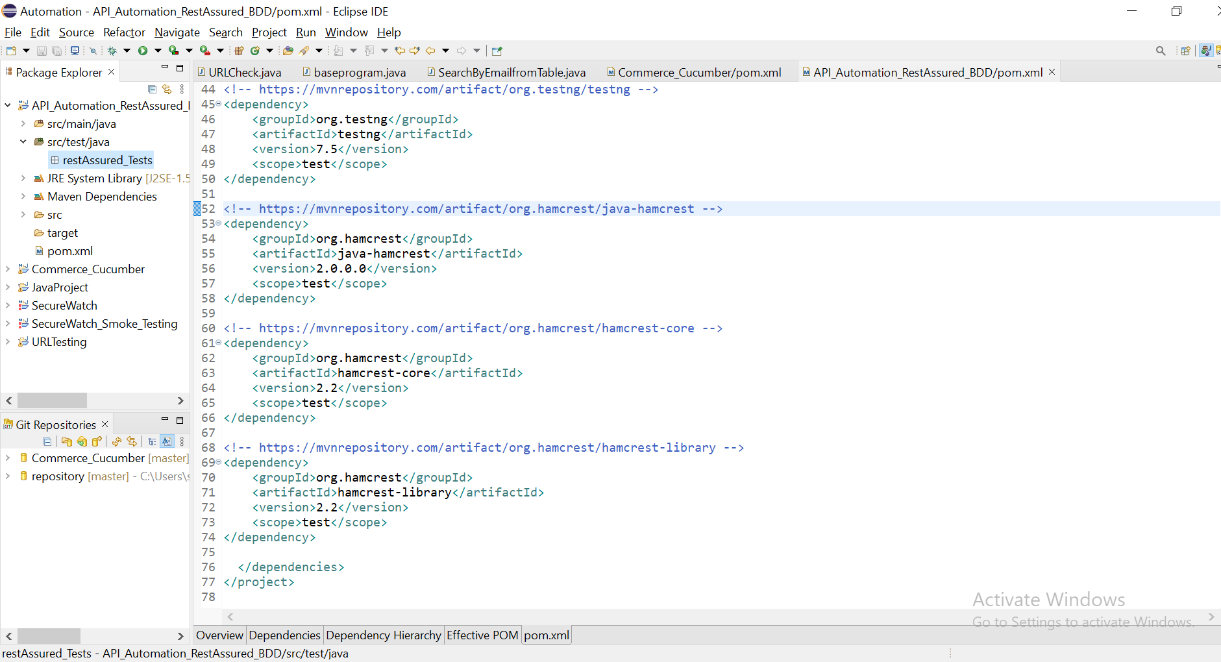

Session-2:

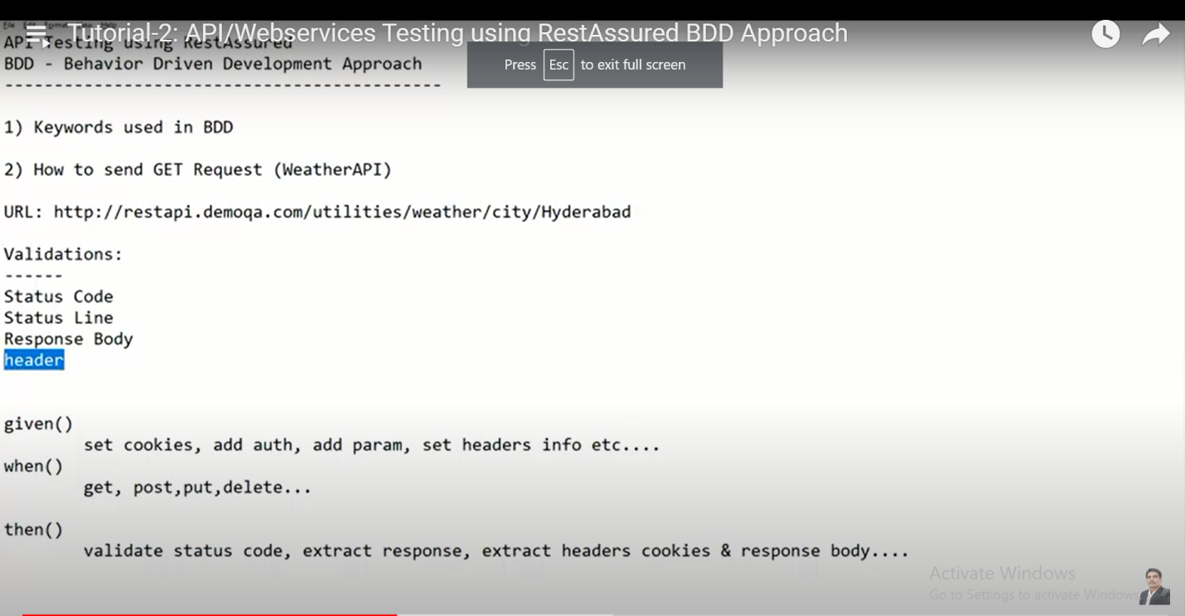

Create new class

